Transferring Data from AudBase to Noah
In AudBase, open the Audiogram you wish to send to Noah and Click the Noah 4 Button
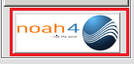
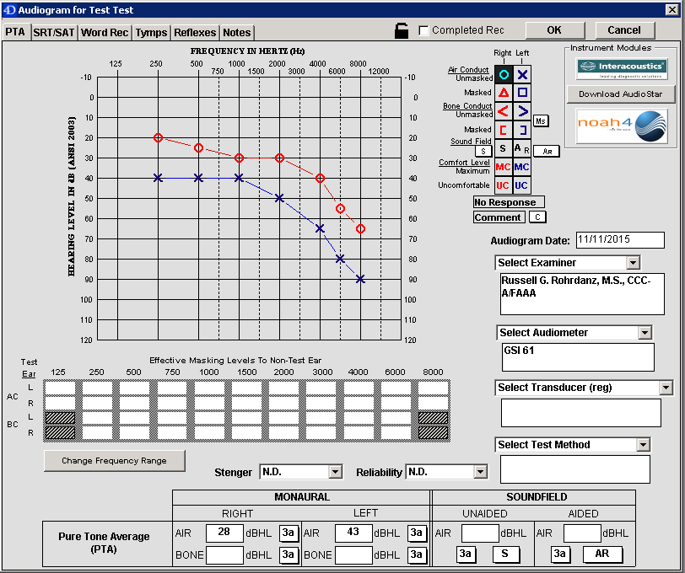
Launch Noah and sign in. You will be prompted to resolve the Patient. Click OK
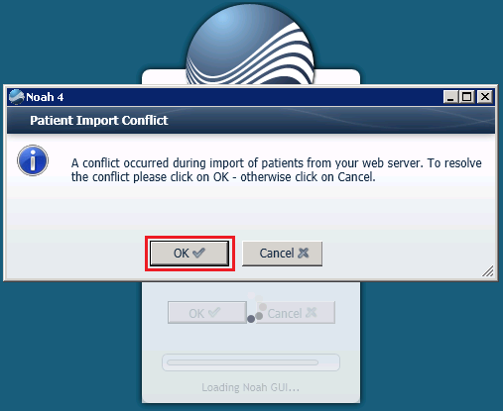
Choose the correct patient and click “Resolve”
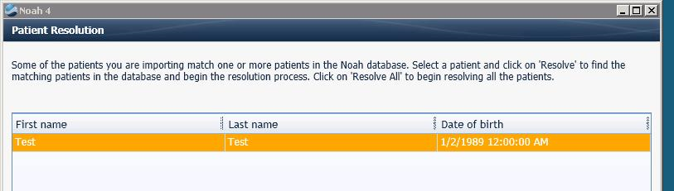
This means Noah wants to determine where to place the data you have sent. You can create a NEW Noah patient, or you can merge this audiogram into an existing Noah patient.

Create a New Noah Patient
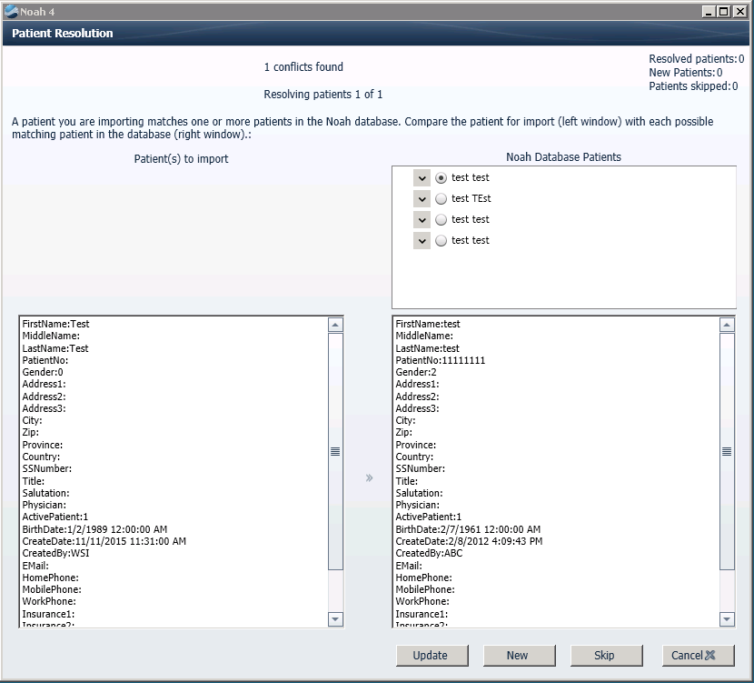
If the patient is New to Noah, select New.

Update an Existing Noah Patient
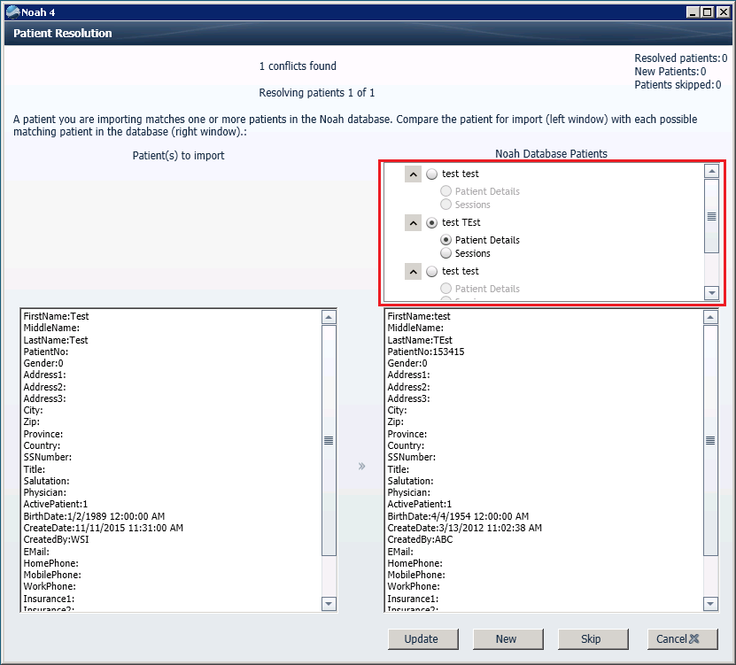
AudBase Patient
Noah will show you all Noah Database Patients that have matching or similar demographics (see red box in the diagram above). When you select a Noah patient, you can view the demographics or session details and compare them to your AudBase patient.
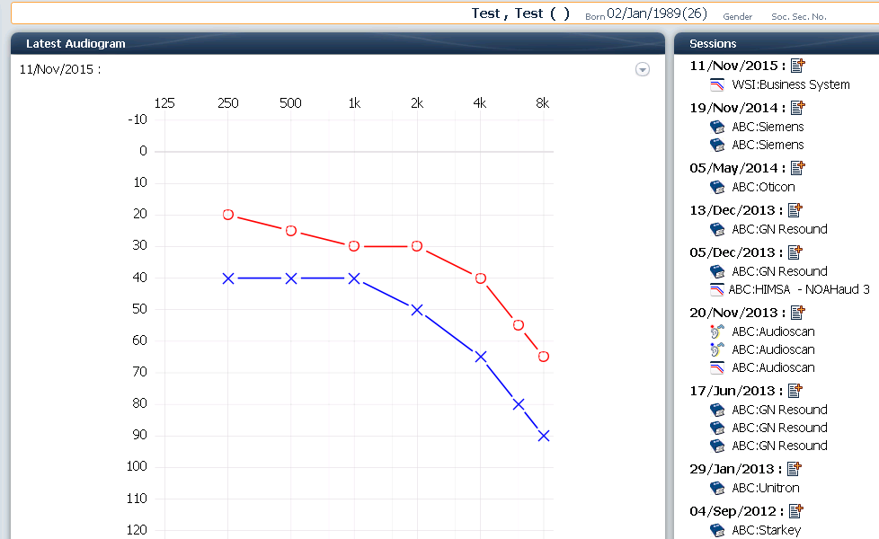
Once you have found the correct patient, click the “Update” button to add this Audiogram to the Noah record. This process will also add and update any additional demographic data from the AudBase patient you are importing.
The audiogram will then be in the appropriate Noah record with a new session as the Audiogram date.

For support, call the AudBase Helpdesk:
1-888-959-6790

