
AudSoft, Inc.
1327 Ashton Drive, Suite 203
Hanover, Maryland 21076

August 21, 2013

To Whom It May Concern:

This letter is to serve notice that our fees for AudBase support services are $175 per hour. For installation of AudBase, there is a minimum one day charge of $1,400. If onsite installation and training is necessary we would add travel charges of no less than $100 per day.

Should you require additional information, please contact me at your convenience.

Respectfully,
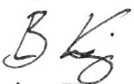
Brian King
AudBase Sales Manager

