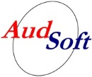
AudSoft, Inc.
1327 Ashton Drive, Suite 203
Hanover, Maryland 21076

May 10, 2013

To Whom It May Concern:

This letter is to serve notice that AudSoft, Inc. owns all marketing rights to AudBase and distributes the software directly to end-users at all U.S. Government facilities.

Additionally, AudSoft is the only facility with trained technical and support staff for AudBase when used with AHLTA.

Should you require additional information, please contact me at your convenience.

Respectfully,
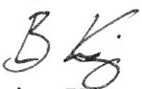
Brian King
AudBase Sales Manager

