
7502 Connelley Drive, Suite 106
Hanover, Maryland 21076
Phone (800) 366-4616

January 1, 2012

To Whom It May Concern:

This letter is to serve notice that Biocoustics Instruments, Inc. owns all marketing rights to AudBase and distributes the software directly to end-users at all U.S. Government facilities.

Additionally, Biocoustics is the only facility with trained technical and support staff for AudBase when used with AHLTA.

Should you require additional information, please contact me at your convenience.

Respectfully,
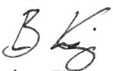
Brian King
AudBase Sales Manager

